09/03/2026
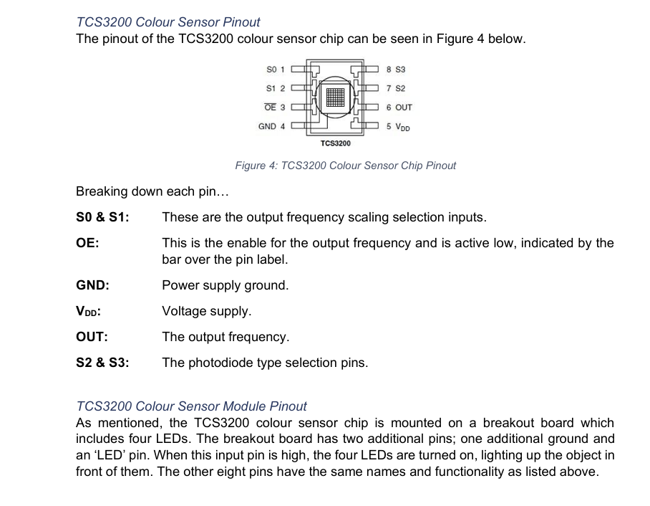
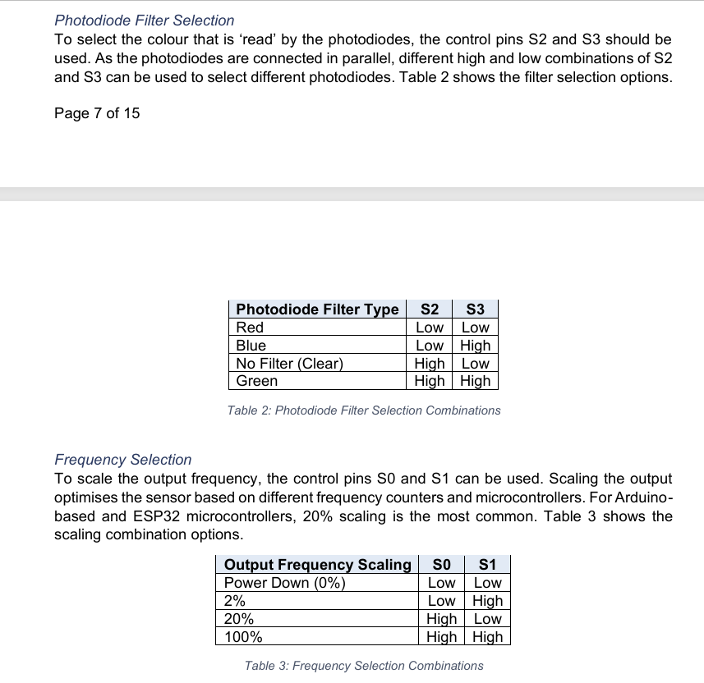

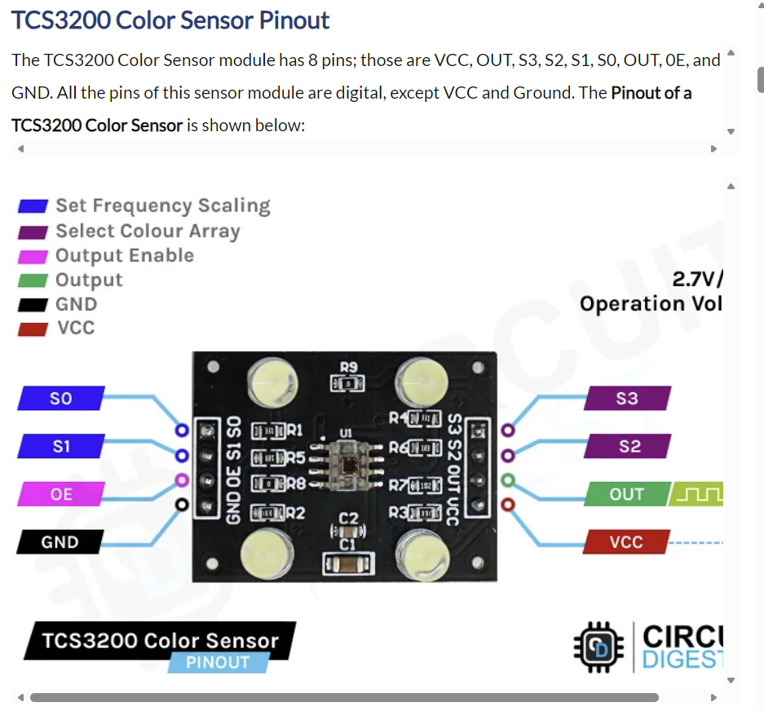
Arduino TCS3200 Color Sensor Tutorial - How TCS3200 Color Sensor Works and Interfacing it with Arduino
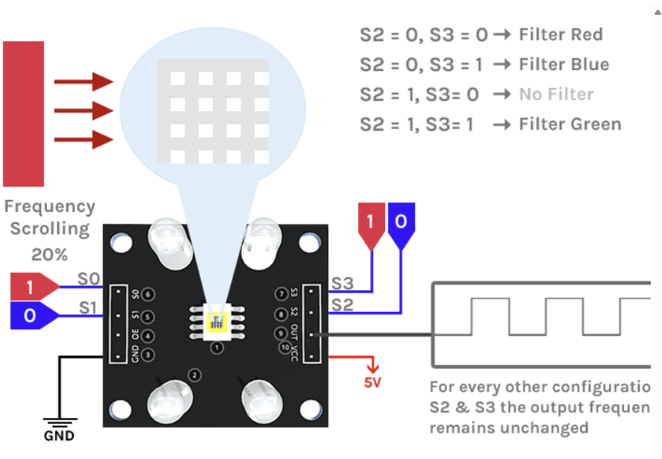
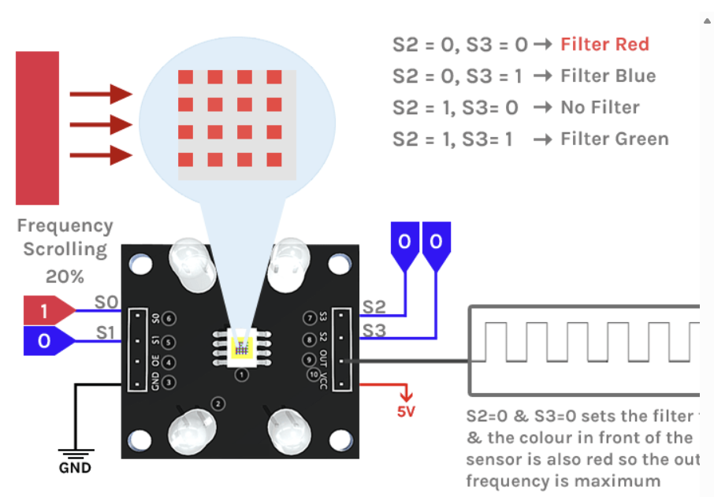
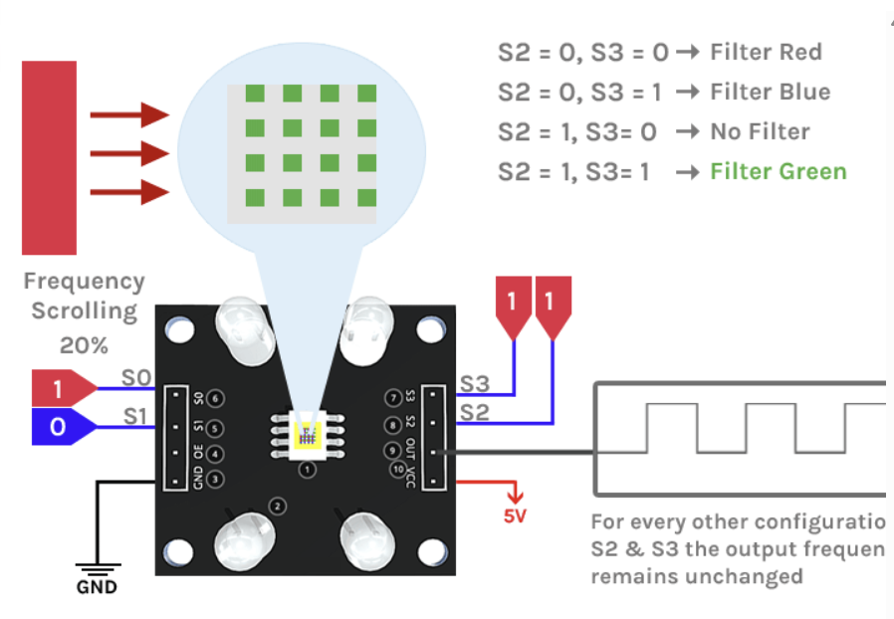
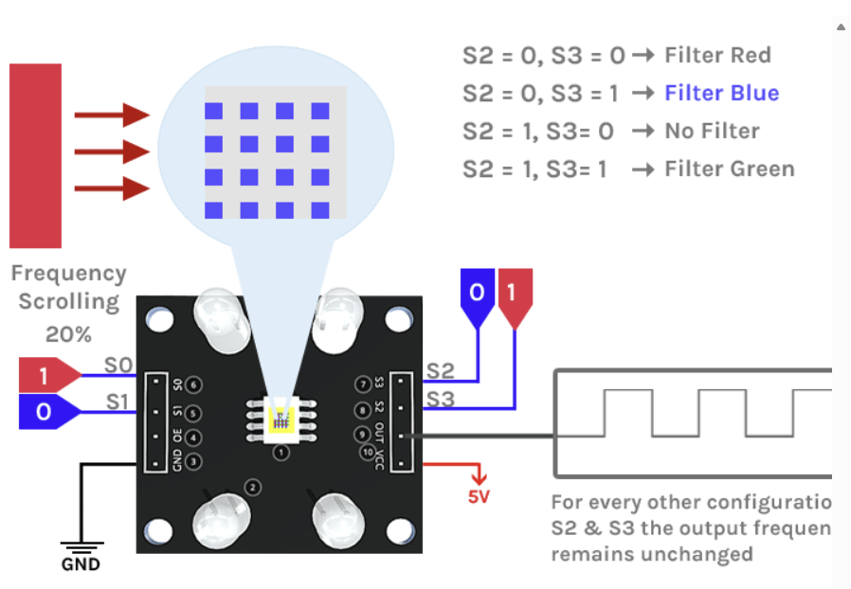
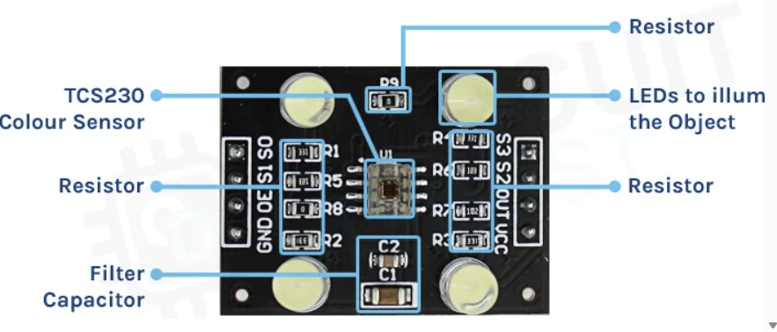
Esp32 Tcs3200 Color Sensor Interfacing With Esp32 | Esp32
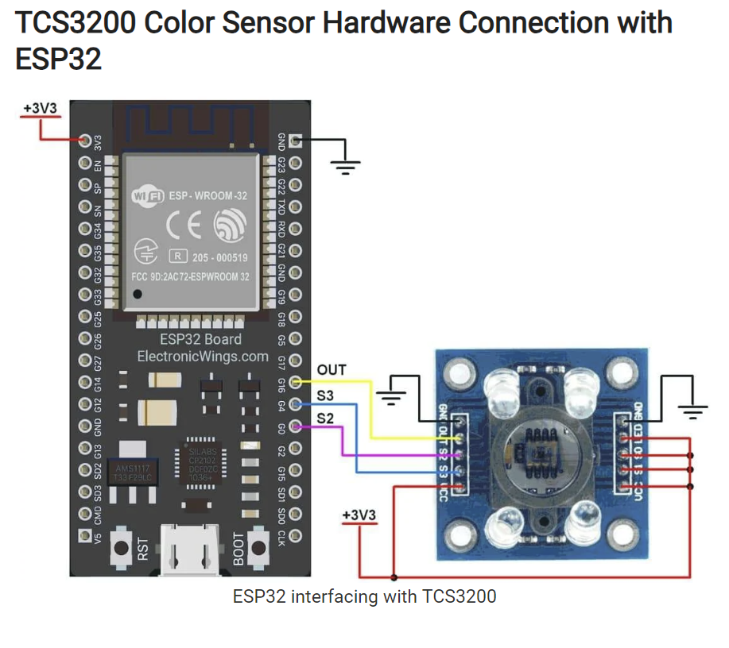
Test code
ESP32 TCS3200 Color Sensor Module example
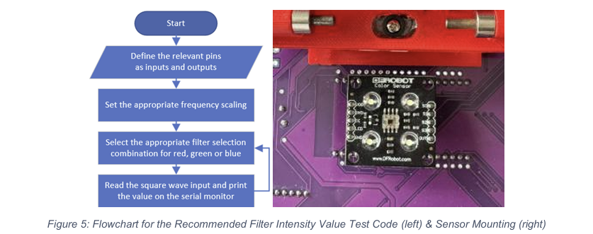
Arduino Color Sensor TCS230 TCS3200 | Random Nerd Tutorials
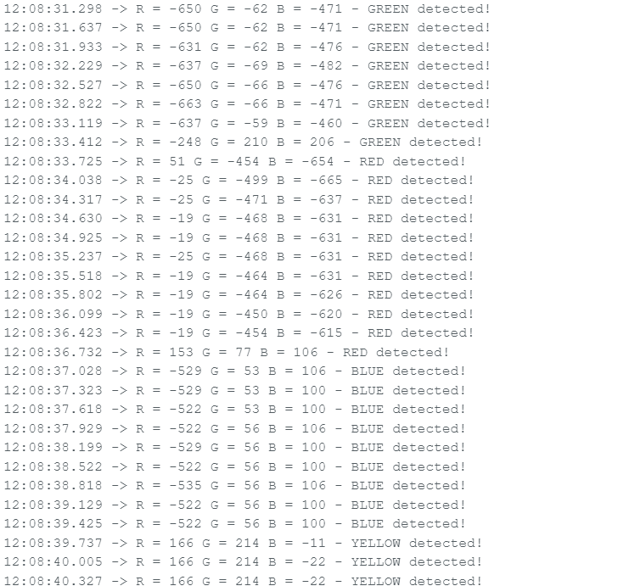
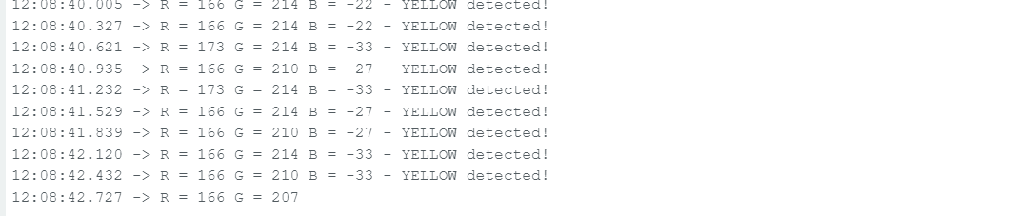
Red Task
ESP32 - NeoPixel LED Strip | ESP32 Tutorial
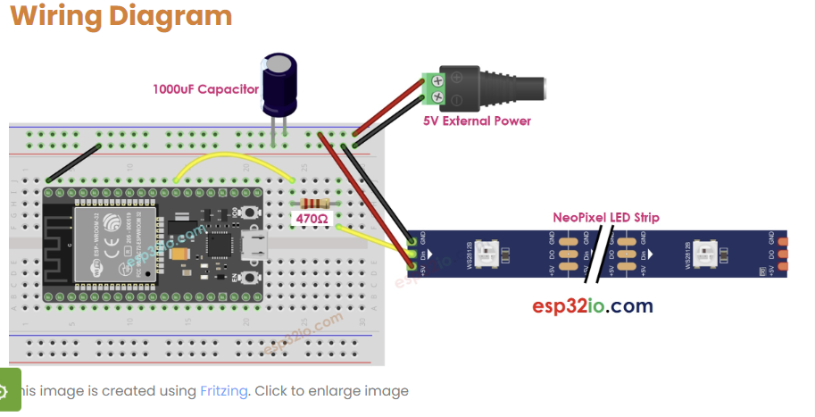
Blue Task
arduino-songs/harrypotter/harrypotter.ino at master · robsoncouto/arduino-songs · GitHub
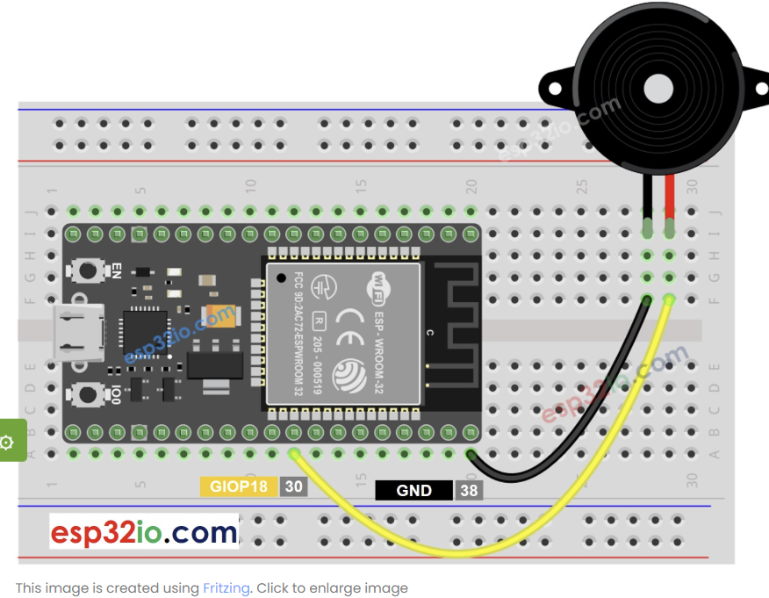
Final Circuit
Testing
